- In an Educational Testing Service (ETS) management system, various modules and interactions would be essential to handle the testing processes. Here's a scenario depicting a similar flow for an ETS management system:
The Test Process Handler Module orchestrates the flow of operations for managing and administering tests within the ETS system. The Get Test Details Module accepts a test ID and retrieves details such as test name, duration, subjects covered, and instructions. The Authentication System Module validates the test-taker's credentials before starting the test whereas the Check Test Eligibility Module validates the test-taker's eligibility to take the test based on criteria such as prerequisites or qualifications. The Test Block Status Module verifies the test-taker's account status and returns a void flag if there are no blocks or issues. The Calculate Available Time Module determines the available time for the test based on the test duration and any time restrictions. The Test Administration Module handles the test-taking interface, displaying questions, accepting answers, and managing the testing environment. The Test Submission Module receives the completed test from the test-taker and initiates the submission process. The Test Evaluation Module evaluates the submitted test, calculates scores, and generates result reports. The Result Processing Module processes test results, generates reports, and updates the candidate's profile with scores and performance metrics. Lastly, Print Test Report Module generates a detailed test report for the test-taker or institutions upon completion.

Tentative solution:
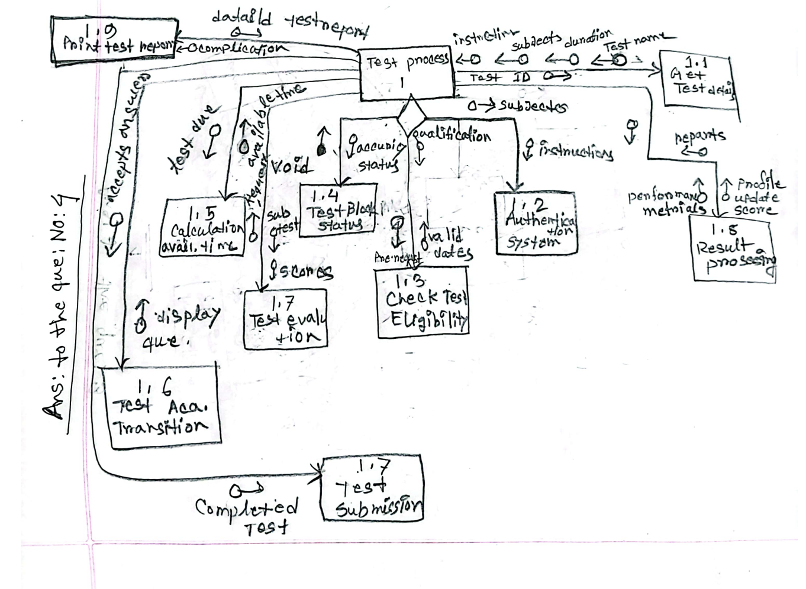
- Electronic Warfare is a very important branch of the military. The US military currently possesses the most advanced Electronic Warfare system. The Electronic Warfare system of the US military is initiated using the Electronic Warfare Mainframe process. Electronic Warfare Mainframe sends calibration signal to Radar Warning module. The Radar Warning module sends Radar Signal Analysis back to Electronic Warfare Mainframe until the radar signal intercepts something, then it sends an interception signal. Compile Report module receives the interception report and status report from Electronic Warfare Mainframe and based on the severity of the situation either sends the status report to compile situation report which is an on page connector or sends both the status report and interception report to compile mission report which is an off-page connector. Radio Frequency counter measure module receives activation signal from Electronic Warfare Mainframe module and extracts enable signal for signal jammer and electromagnetic spoofing module and forwards them to their respective modules. The signal jammer and electromagnetic spoofing module will keep running until the signal jammer module sends a timeout flag back to the radio frequency countermeasures module. Electronic Warfare Mainframe module uses a library module called geospatial location exploitation system which receives coordinates as input and sends back analysis reports for mapping purposes.

Tentative Solution:
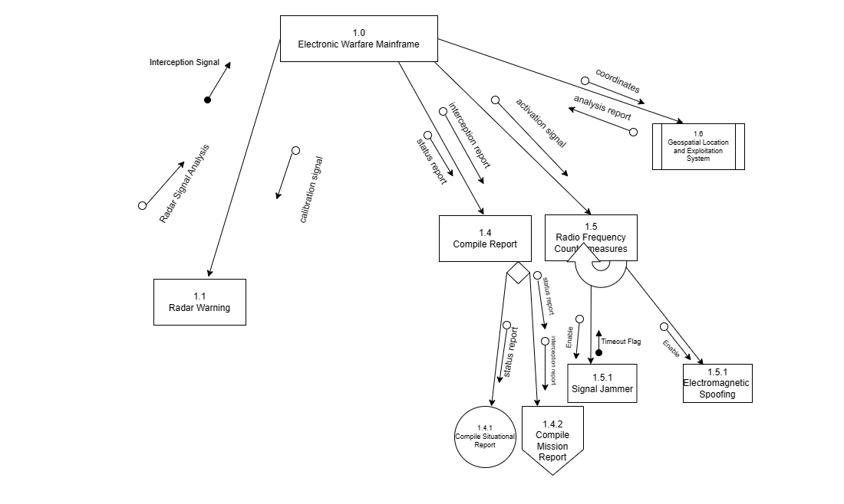

Remember to label each component and illustrate the relationships between them. Indicate the flow of data or control between the components to demonstrate the interactions within the production line management system of the manufacturing company.

- A company’s payroll system automates the process of calculating employees’ salaries and printing paychecks.
The Generate Payroll (GP) function begins by gathering the payroll records of employees. Initially, valid employee records are retrieved by the GP from "Get Payroll Record” (GPR) followed by an end-of-payroll message. The GPR consists of two sub-functions: Read Payroll Record (RPR) and Validate Payroll Record (VPR). The RPR reads and sends payroll records until it reaches the end of the file. Subsequently, GPR sends the payroll records to VPR to check their validity and receives a valid record signal.
Once the records are validated, they are sent to Calculate Net Pay (CNP), which returns payroll check data as a flag to the GP. CNP receives gross pay from Calculate Gross Pay by sending the employee ID and hours worked. The gross pay, along with the employee ID, is then sent to Calculate Deductions (CD), which returns the total deductions amount. CD passes the gross pay and tax status to Calculate Tax Withheld, and the gross pay to Calculate SS Withheld. Tax withheld and SS withheld are output from these two functions, respectively. Additionally, CNP calls the Update Employee Record process by sending the employee ID, gross pay, and total deductions.
Finally, the GP forwards the payroll check data to an off-page connector, Print Check (PC), which sends back a check print couple to the GP. The GP will repeatedly call the GPR, CNP, and PC.

Tentative Solution:
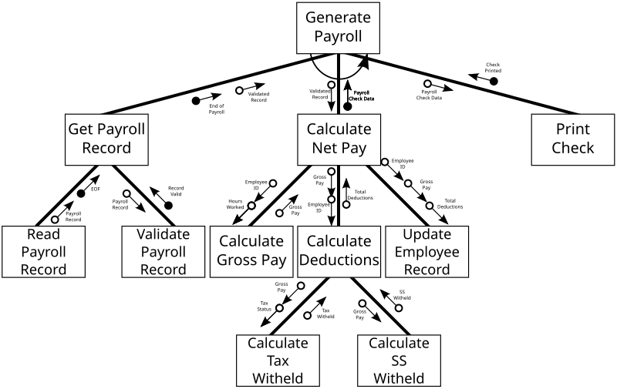
- A manufacturing company wants to develop a system for managing their production line. Draw a structural diagram that represents the main components and their relationships within the system. The User Interface (UI) component handles the display and interaction of the system's interface. It takes production parameters as inputs, it monitors production progress, and outputs results after viewing reports. The User Authentication component manages user authentication and authorization processes. It takes in user credentials as inputs, and allows user logins if it is verified. The Production Control component oversees the overall production process. It receives input from the UI component, and it outputs production progress after monitoring, and provides control signals. The Inventory Management component handles the management of raw materials and finished goods inventory. It tracks inventory levels, triggers reordering when necessary, and updates inventory records based on production outputs. The Workstation Control: This component manages the individual workstations in the production line. It receives instructions from the Production Control component, controls the operation of each workstation, and provides status updates.
The Quality Control component ensures the quality of products during the production process. It performs inspections, collects data on product quality, and communicates quality feedback to the Production Control component. The Reporting and Analytics component generates reports and provides data analytics functionalities. It collects data from all the other components, processes it, and presents insights and reports to the system. The Database component stores and manages data related to production parameters, inventory records, quality control data, and other relevant information. It provides the necessary data storage and retrieval capabilities for the system's functionality.

